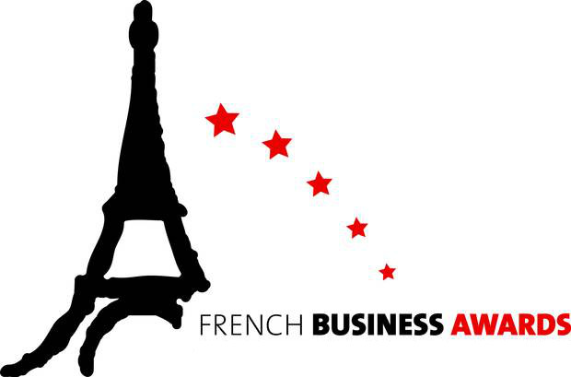
FRENCH BUSINESS AWARDS 2019
Application Form
About the Awards
Organized for the first time, the French People’s choice Awards in partnership with Le Petit Journal Auckland honor excellence.
Best French Restaurant in New Zealand Award: This award in partnership with Le Petit Journal Auckland recognizes the best French Restaurant which operates in New Zealand.
Best French Bakery in New Zealand Award : This award in partnership with Le Petit Journal Auckland recognizes the best French Boulangerie and/or Pâtisserie which operates in New Zealand.

Fees : Free for FNZCCI Members / $100 for Non-members
The deadline for the submission of your application is Sunday, September 15, 2019.
Public vote from 16/09/2019 to 06/10/2019.
Please submit your completed application as soon as possible as spots are limited for each category!
Please choose the awards you are applying for. Note that if you are applying for more than one award, you must send the form for each one.

- Best French Bakery Award | ☐
- Best French Restaurant Award | ☐

_________________________________________________________________________
SECTION 1: ABOUT YOUR COMPANY
_________________________________________________________________________

General information

Name of the company: ___________________________________________

Date of creation or operating in New Zealand: ____________________________________

President / Managing Director name and title: _____________________________________

_________________________________________________________________________

Is your company a subsidiary of a large group / corporation? Yes / No

If you answered ‘Yes’, what is the country of origin of your company? :__________________

Main contact person for the purpose of this contest:

Name: ___________________________________________

Title: ___________________________________________

Email: ___________________________________________

Tel.: ___________________________________________

_________________________________________________________________________

SECTION 2: ABSTRACT
_________________________________________________________________________

Please explain your main activities in a short abstract in English. This abstract will be used for the press releases following the event. It will also help the jury come to a decision.

English abstract
700 characters max. Spaces included

_________________________________________________________________________

_________________________________________________________________________

_________________________________________________________________________

_________________________________________________________________________

_________________________________________________________________________

_________________________________________________________________________

_________________________________________________________________________

________________________________________________________________________

YOUR INTERVIEW IN "LE PETIT JOURNAL NOUVELLE-ZELANDE"
_________________________________________________________________________

Please answers the questions below from our co-organiser Le Petit Journal for publication on https://lepetitjournal.com/auckland

Le Petit Journal: Bonjour, could you please present us your business (name, your specialities, your clients, what you are known for, ...)
You:_______________________________________________________________________________________________

Le Petit Journal: When did your business start operating, and what is/are your location(s) and opening hours?
You:_______________________________________________________________________________________________

Le Petit Journal: What makes your business unique / why do you think you deserve the public to elect you the best of your kind in New Zealand?
You:_______________________________________________________________________________________________

____________________ ____________________
Name of the applicant Date

Additional information:
After completing all mandatory sections of the form, please feel free to add any additional information you think relevant to support your application. For instance, it can take the form of a press book.
Please send us along with this form the logo of your company in high definition with a transparent background, preferably in .ai or .png format and 2 photos of your business (portrait and landscape mode).

Application forms should be returned by e-mail to:

contact@fnzcci.org.nz

The deadline for the submission of your application is Sunday, September 15, 2019.

For further information:
Marianne Montbailly, Business Developer Coordinator (English/French)
Tel.: 021 0805 8908
E-mail: contact@fnzcci.org.nz
Hélène Toury, Awards & Communication manager (English/French)
Tel.: 021 024 86944
E-mail: htouryfnzcci@gmail.com
Thibault Beaujot, Project director (English/French)
Tel. : 021 580 563
E-mail : president@fnzcci.org.nz

